**THESIS PROFORMA**

Patient Name: Date:

Age: OP.no:

Gender:

**CLINICAL PARAMETERS:**

PROBING POCKET DEPTH:

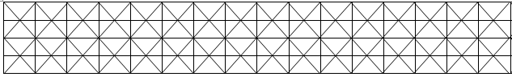

CLINICAL ATTACHMENT LOSS:



GINGIVAL RECESSION:

|  |  |  |  |  |  |  |  |  |  |  |  |  |  |  |  |
| --- | --- | --- | --- | --- | --- | --- | --- | --- | --- | --- | --- | --- | --- | --- | --- |
|  |  |  |  |  |  |  |  |  |  |  |  |  |  |  |  |
|  |  |  |  |  |  |  |  |  |  |  |  |  |  |  |  |

PLAQUE INDEX (SILNESS & LOE):

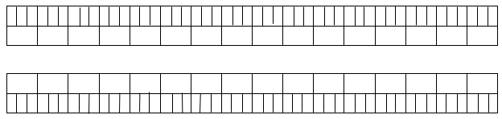

GINGIVAL INDEX (LOE & SILNESS):



VISUAL ANALOUGE SCALE:

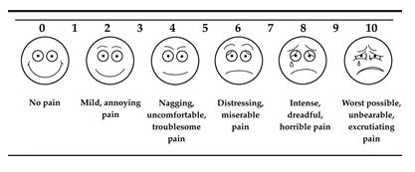

EARLY WOUND HEALING INDEX:

|  |  |
| --- | --- |
| GROUP A | GROUP B |
|  |  |